“Is online Education Better than the Classroom Education?”
Institution Affiliation
Tutor
Name

Background
Both online education and classroom education have merits and demerits. The real question that an individual ought to ask himself or herself is: which is better for the person? In the current job market, workers have decided to be part of those who have embraced lifelong learning as part of their career plan. The workers and the students have now a variety of option concerning the mode of learning that suits their needs (NU, 2015). The different needs of both the working and learning people and those of the students have made the learning institutions to adapt to the diverse needs of the ever-growing student population. Today's learners often find themselves required to commit themselves with family and job commitment far beyond solely earning a degree. In response to the arising needs by the increasing number and categories of students, colleges and universities have come up with academic pathways which are more flexible.
The question arises concerning another of factors such as; an individual's work status if the person has got a busy schedule where he or she has to balance between say, for instance, going to school and a full-time job. Another factor is that of residence or where the person lives; for the people who work and at the same time learns, in most cases will find online learning being better for them. The family is another factor that has to be selected when picking on the best learning style. Balancing work, school, and life is not easy and thus an individual will need a program that will give him or her the flexibility that is he needs. And lastly, is the factor concerning an individual's learning style; online education will provide a learner with several channels through which communication can be carried out such as email, online chat, and video conferencing (NU, 2015). Whereas, in classroom education, it will entail the means of interacting mention above and also in-person opportunities.
Claim
Online education tools provide learners and educators with access to resources that they could not have accessed otherwise, regardless of their status and their location.
Ground/Evidence
Currently, online education has become a trend. Many learning institutions have embraced it and have begun to go the virtual way. However, there are also those institutions that still realize the benefits of having in place the classroom education. Also, it has been found out that, classroom education not only impacts the learners but also the teachers. The classroom education system requires the students to attend in person. This has been seen as the most common way of learning, but it has experienced a decline in traditional learning institution enrollment. The percentage of students who have been enrolling for the classroom learning has declined since 2014 as shown in the table below:
Percent of College Students Enrolled in Classroom learning
Year | Percentage (%)
2014 | 75
2015 | 70
2016 | 68
Online education to have been liked by many learners around the globe. While online education saw increases, in classroom education saw some slight year-to-year decrease from 2014 to 2016 (Purdue Global University, 2018).
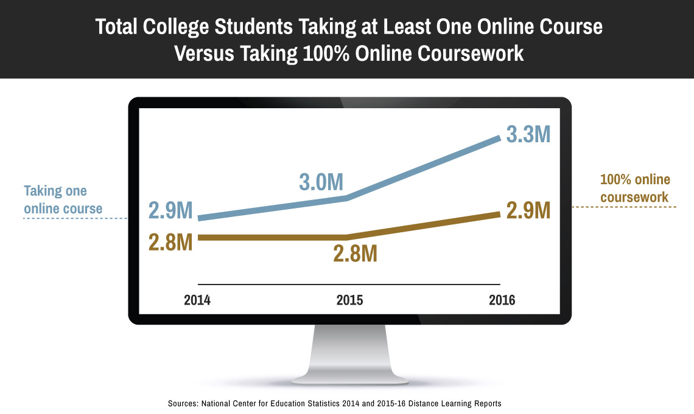
https://www.purdueglobal.edu/news-and-resources/articles-blogs-news/total-college-students-taking-at-least-one-online-course-versus-100-percent-online.jpg
Many of the students who have joined online education have been attracted by the convenience that it has presented to them. It presents convenience and flexibility that allows the learners to study any time, and also it can be taken from anywhere provided there will be access to an internet connection (Purdue Global University, 2018). It has received applaud from the people who have demanding work schedules or even have the family obligation that need to be catered for. Online education gives the chance for a learner to pause the content and/ or even go back to an area of learning that they did not get clearly or they want to refresh their memory (De, 2018). The latter is an incredible thing that really helps a student to spend some extra time on a challenging topic.
Warrant
Online education has strived to copy the social media aspects that are connected to a classroom with tools such as messaging boards, chatbots, and even Facebook groups. Such chatting boards provide the learners with a sense that they are not just starting to an empty messaging board, but that they are chatting with real people on the other side (De, 2018). Such boards give the learners and their tutors a chance to expound on any rising issue concerning learning materials or concepts that they need some explanation about. The students interact as though they are in class, the messaging boards gives them the chance to discuss any problem and if they did not provide a solution, they can always chat with the tutor concerning the problem (Reddy, 2018). The tutor then provides a solution to the issue with illustrations if need be. There are also other means of e-learning such as teleconferencing where the students and the teacher get connected and hold the discussion as a virtual class. It is convenient to hold virtual classes since there are those students or even working people who have got a tight schedule and thus cannot make attending a classroom.
Online education can entail pre-recorded videos with the tutor teaching. The recorded video usually entails precise and clear-cut feedback concerning how the learners engaged with the learning materials. The tutor gets to pinpoint where the student got lost and hence make the necessary efforts to compensate for that by making corrections or even going ahead and providing clearer content. This is normally done by a click of a button (Reddy, 2018). Online education has been necessitated by the arising needs of the learners. Currently, many of the learners have been driven to self-instruction by the fact that many of them are excited about how it operates or simply because some cannot afford to pay for their school tuition fee. The platforms that are geared towards offering online education have been made in such a way that they cater to the content and interaction of the learners; their interest, location and even their speed. Online education has offered the ability to students whatever they need, from wherever they are located.

References
De, B. (2018). Traditional Learning Vs. Online Learning. E-Learning Industry.
NU. (2015). Online Education vs Classroom Education. Norwich EDU.
Purdue Global University. (2018, 10 22). PurdueGlobal.edu. Retrieved from https://www.purdueglobal.edu/news-resources/classroom-versus-online/
Reddy, D. (2018). Will Online Education Replace Classroom Education Anytime Soon? Forbes.

